ANA 610 Homework #3

Please refer to the assignment “grading rubric” for point allocation.
Please read the directions carefully.

Continuing our analysis of the Donor datafile (s_pml_donor_hw_v3), refer to “Data Dictionary – Donor.pdf” for data field definitions and your data audit performed for Homework #1.

Task #1 (92 pts):

Check the variable LIFETIME_GIFT_AMOUNT for extreme values using the following 5 techniques: “PROC EYEBALL”, top/bottom X%, interquartile range, clustering and statistical.

- First, in table format, perform a quick data integrity check on LIFETIME_GIFT_AMOUNT (using R or SAS) and identify all issues which may exist with respect to this variable.

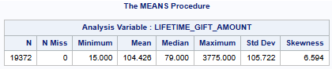

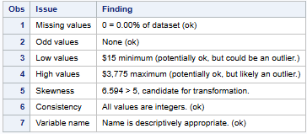

- Second, using SAS, summarize your findings from the first 4 extreme value checking methods using the following table template. Use the shown Benchmark Parameters and all records in the datafile. Your answers should be supported by SAS code in your submitted SAS program.

 | LIFETIME_GIFT_AMOUNT
Technique | Benchmark Parameter(s) | Low Extremes (cutoff value) | High Extremes (cutoff value) | Extremes  (count > cutoff) | Extremes  (% of file)
PROC EYEBALL | >750.00 | 0.00 | 750.00 | 48 | 0.25
Top/Bottom X% | 1% | 15.00 | 491.00 | 192 | 0.99
IQR | 3*IQR | -228.00 (0.00) | 402.00 | 344 | 1.78
Clustering | pmin=.006 | 0.00 | 945.00 | 26 | 0.13
Grubbs test | p-value = 0.05 | 0.00 | 430.00 | 286 | 1.48

- Third, using R, summarize your findings from the 5th extreme value checking method, the Grubbs test. Use grubbs.test() from the outlier package. Show your neatly formatted R generated output here which supports your findings.

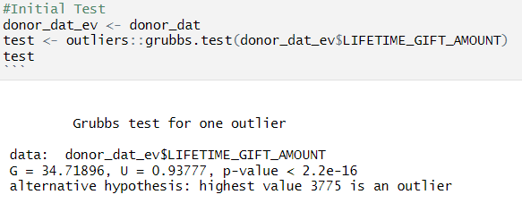

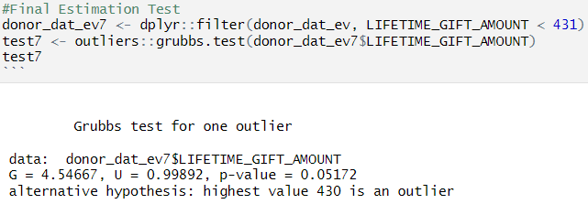

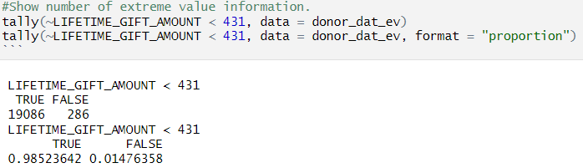

- Fourth, discuss fully (a) whether there are any extreme values (i.e., what cutoff value(s) do you recommend and why); and (b) if so, recommend what should be done about them.

NOTE: After applying the 5 techniques, you will find extremes values (we can usually always find extreme values by varying the benchmark parameter). But, considering all 5 techniques jointly using the assigned benchmark parameters, together with how the variable is defined, what is (are) your recommended cutoff value(s) for an extreme value of the variable (and why).

Your discussion should address both low- and high-end cutoff/extreme values, explicitly consider the distribution of the variable in question, make use of charts, compare findings across the various methods, and provide sufficient support of your recommendation.

- Concerning LIFETIME_GIFT_AMOUNT, what the values are and what they represent does not seem extreme. Although, the distribution of the values could be a potential problem if the variable is used for modeling. See the histogram and boxplot below.

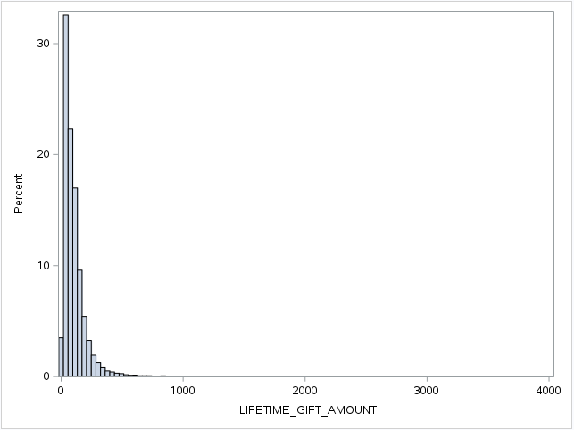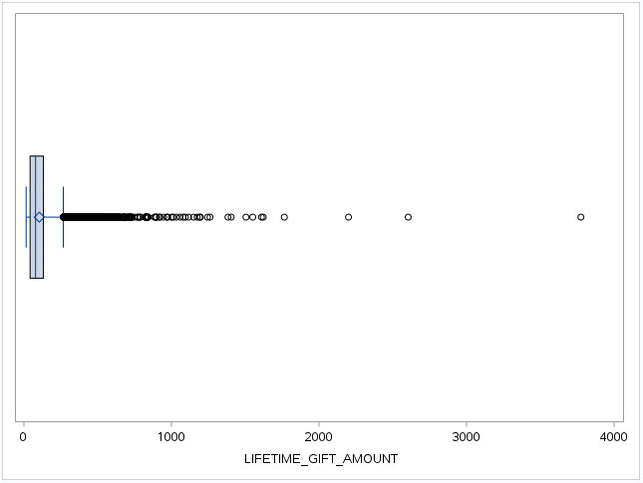

Imagine that using the PROC EYEBALL method as an extreme value test is not the worst option, especially if the experienced data scientist has viewed numerous distributions in the past and needs a quick method method to generate results. I am a data scientist in the making, but was able to identify 48 extreme values about 0.25% of the file. Ideally, a more statistically based method would be preferable.

The significant right skew of the original distribution makes the use of extreme value tests like Top/Bottom 1%, IQR, and Grubbs less desirable, because they are better suited for a more normal distribution. Although their parameters could be modified to try to accommodate the skewed distribution, it may be more difficult to settle on what those parameters should be. All three of these methods identified way too many extreme values to be considered.

- Viewed the Clustering method of identifying extreme values as being completely appropriate for this type of distribution of values. It identifies single extreme values by using a percentage of a single sample vs. the total population (1/19,372). With a $945.00 calculated cut-off value, the Clustering method identified 26 extreme outliers. See the tally and histogram below.

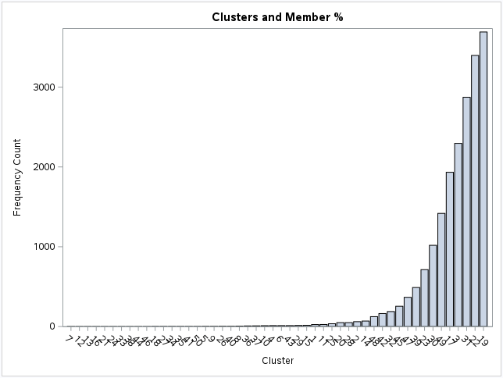

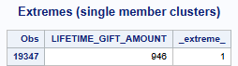

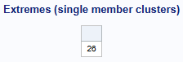

Given that all of the values for LIFETIME_GIFT_AMOUNT are probably legitimate, any exclusion of extreme values would definitely need to have client consent. Knowing that the original distribution has a significant right skew that should be addressed through transformation, it would probably make more sense to use the extreme value tests to identify extreme values on the logarithmically transformed data. After model testing the transformed distribution, a modified transformed distribution with the identified extreme values removed could be tested as well to see which would perform better.

A logarithmic transformation could do much to resolve the right skew of the values, but there are still notable outliers after the transformation. See the histogram on the next page.
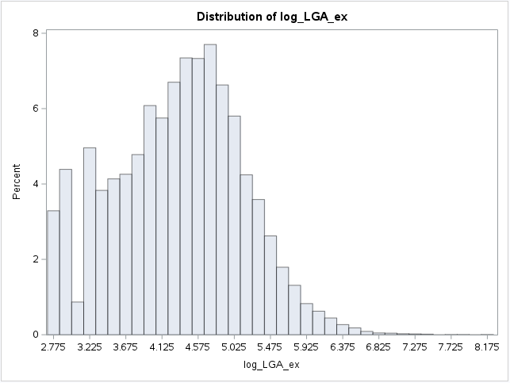

Task #2 (78 pts):

- To avoid model overfitting issues, threshold coding can result in fewer dummy variables than there are levels (categories) of the categorical variable.
  - First, in table format, perform a quick data integrity check on RECENT_STAR_STATUS (using R or SAS) and identify all issues which may exist with respect to this variable.

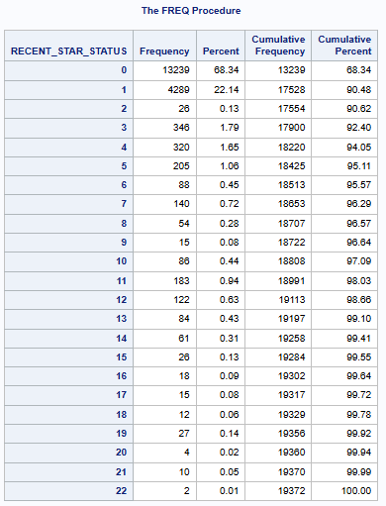
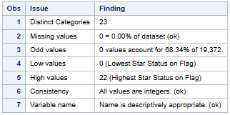

  - Calculate the (1) cardinality and (2) cardinality ratio for RECENT_STAR_STATUS. What does this value imply for the potential recoding methods which can be used? Explain fully.
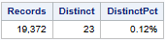

      - Low Cardinality with 23 Distinct Categories
      - Cardinality Ratio = 23/19,372 = 0.12%

Low cardinality inputs are acceptable for most modeling techniques, indicative of a discrete variable, and present no danger of overfitting using simple recoding techniques.

  - Show your neatly formatted SAS code here for how you would recode RECENT_STAR_STATUS into dummy variables considering a threshold value of 30. Use descriptive dummy variable names.

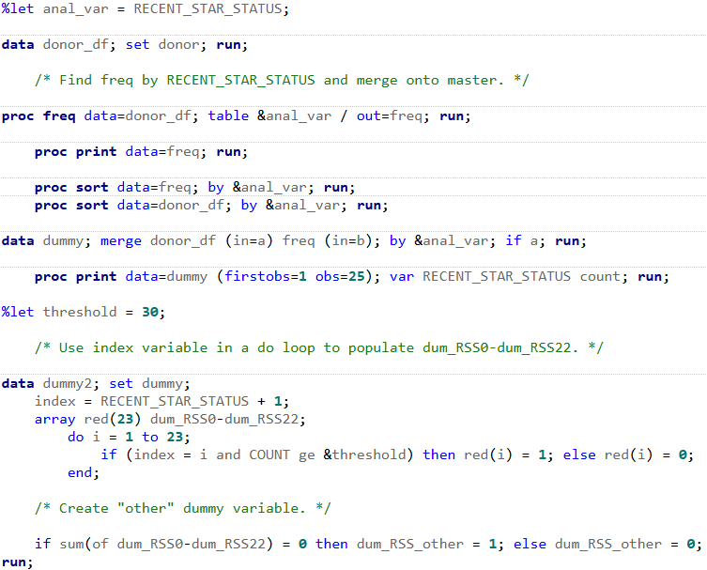
  - Show your neatly formatted R code here for how you would recode RECENT_STAR_STATUS into dummy variables considering a threshold value of 30. Use descriptive dummy variable names.

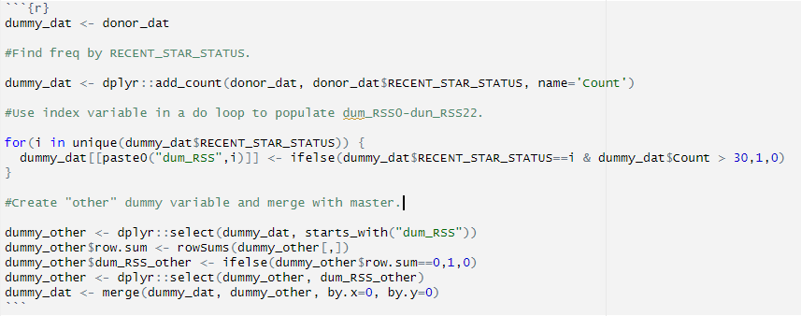

  - Execute your code, and
    - Show here an R-generated output table (neatly formatted) which reports the MIN, MEAN, MAX and STD for each dummy variable (in one table).

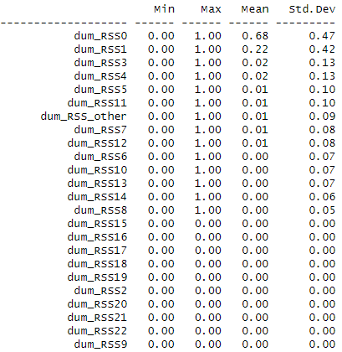

    - Show here an SAS-generated output table which reports the MIN, MEAN, MAX and STD for each dummy variable (in one table).

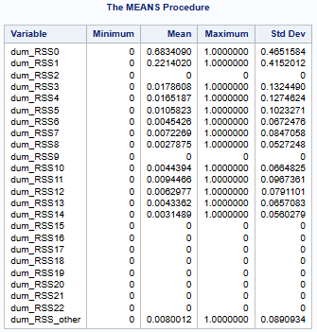

    - Explain what each statistic (MIN, MEAN, MAX and STD) can tell you specifically about your dummy variables.

The minimum value of 0 and the maximum value of 1 are binary representations of whether a specific RECENT_STAR_STATUS value appeared in the dataset (0 for no, and 1 for yes). All dummy variables with a maximum value of 0 did not possess greater than 30 recorded entries in the dataset and were grouped into the dum_RSS_other variable to reduce potential overfitting in predictive model use, and consequently had 0 values for mean and standard deviation as well. The mean value indicates the proportion of total recorded entries that were related to the specific RECENT_STAR_STATUS value. The standard deviation value represents a calculation of the average deviation from the mean value of each utilized dummy variable.

  - Using either R or SAS, check that the sum of each dummy variable is indeed at least 30 for each dummy variable that passes the threshold test.
    - Show here a code-generated, neatly formatted output table which reports the SUM for each dummy variable.

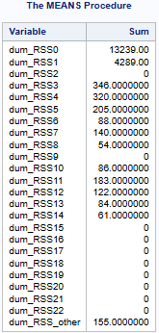

    - For dummy variables with SUM = 0, where do the associated datafile records get accounted for? Explain fully.

All dummy variables with SUM = 0 did not possess greater than 30 recorded entries in the dataset and were grouped into the dum_RSS_other variable to reduce potential overfitting in predictive model use.

  - Using either R or SAS, check whether the SUM for each dummy variable is at least 30 for each segment of TARGET_B, the target variable for a predictive model of likelihood to donate.
    - Show here a code-generated, neatly formatted output table which reports the SUM for each dummy variable by target variable segment.

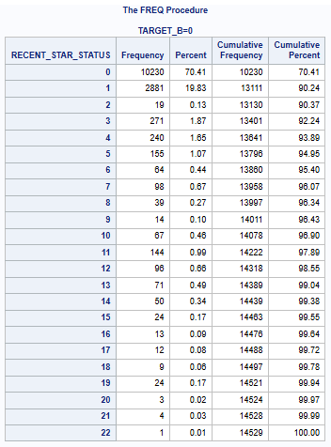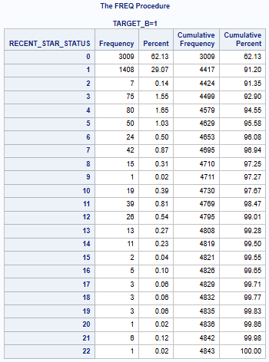

- In 1(g) you should have found that the threshold is not met for some of your created dummy variables at the target variable segment level.
  - Using either R or SAS, show your neatly formatted code here for how you would then create a new set of dummy variables, only if the SUM is at least 30 in both TARGET_B segments.

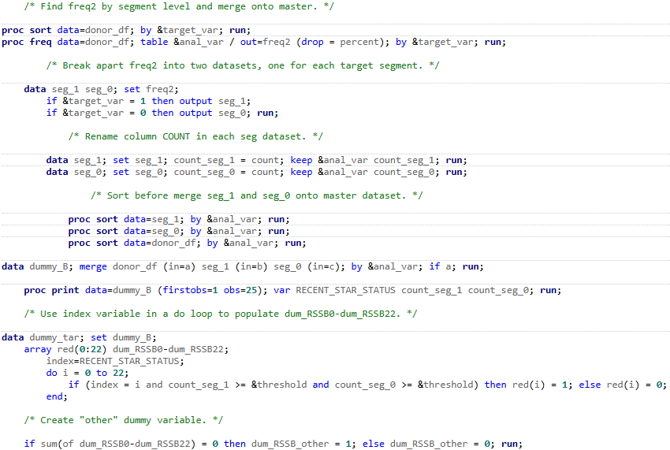

  - Show here a code-generated, neatly formatted output table which shows that the SUM for each of your dummies created in 2(a) is indeed at least 30 in each TARGET_B segment.

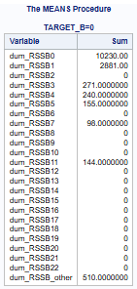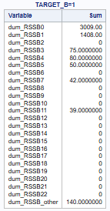

NOTE: SAS arrays should start with “1”. Although RECENT_STAR_STATUS is coded numerically, it starts with 0 and SAS will ignore the 0 in an array. So, if you use an array (you can use a more direct approach if you prefer), create an index variable as shown in the example SAS code using _n_ or create an index = RECENT_STAR_STATUS + 1.

Task #3 (50 pts):

Another remedy for sparseness in the levels of categorical variables is to collapse the levels using a statistical approach. Continue considering TARGET_B as the target variable.
Using SAS’s PROC CLUSTER and the process presented in lecture, determine the optimal number of clusters for RECENT_STAR_STATUS and create dummy variables for these clusters.

  - Using PROC FREQ, first calculate the Pearson chi-square statistic. Use RECENT_STAR_STATUS as the row variable and TARGET_B as the column variable. Is there a statistical association between RECENT_STAR_STATUS and TARGET_B? Explain fully. Display relevant output from PROC FREQ.

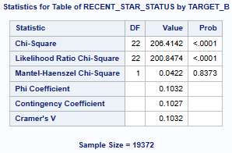

The very high Chi-Squared value of 206.4 is an indicator of statistical association. Given the extremely low Chi-Squared p-value of <.0001 is less than an alpha of 0.050, we can reject the NULL hypothesis of no statistical association, and conclude that there is some relationship between RECENT_STAR_STATUS and TARGET_B.

  - Show the tree chart (dendrogram) created by PROC CLUSTER and indicate your guess of the number of clusters based solely on this tree chart. Circle your guesses on the tree chart. Explain fully your guess as it relates to just the information shown by this tree chart, specifically the x-axis.

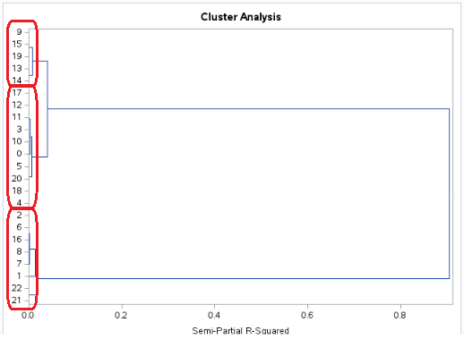

Had the gift of hindsight after working through this section of lecture video, but as you view from the right to left parallel to the x-axis you can see how branches start to diverge at certain Semi Partial R-Squared levels, and after moving over two levels of divergence three clusters were formed. The dendrogram did not offer a completely clear designation of the clusters due to the positioning of the branches, leaving the observer wondering about the extent of each cluster.

  - What is the optimal number of clusters? Explain fully including the statistical logic behind the optimal number. Support your answer with the plot of the log p-value.

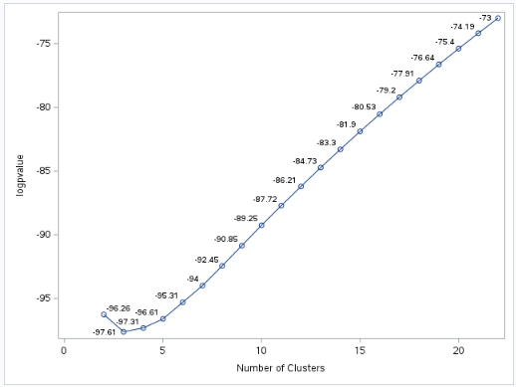

In the plot above, each potential number of clusters is evaluated with the Chi-Square method, a logarithm is taken of its generated p-value, and plotted in the chart. The optimal number of clusters correlates with the lowest logarithm of the p-value. In this case, the optimal number of clusters was three.

  - Show a table with the cluster assignments of the levels for RECENT_STAR_STATUS. Show and discuss why your guess of the number of clusters did or did not differ from the optimal number.

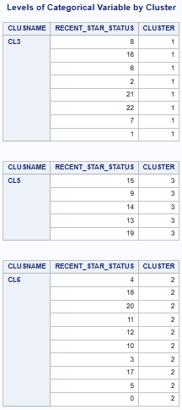

As previously stated, I had the gift of hindsight in my choice, so it matched up perfectly. In addition, the dendrogram could have done a little better job of clearly designating the clusters. Regarding the formed clusters for RECENT_STAR_STATUS, I think the clustering would have been better honoring the ordinal nature of the variable. Could easily see a variable value of 0 having its own cluster. Not sure that the Greenacre strategy is totally appropriate for this variable, but can imagine many variables where it would be.

  - Show your neatly formatted SAS code for how you would create dummy variables (with descriptive names) for these cluster assignments.

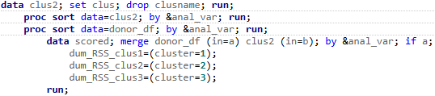

  - Show a SAS output table with the frequencies of the new cluster dummy variables.

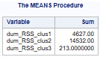

  - Check and show here, using the relevant SAS output table, that for each cluster dummy variable, SUM is at least 30 in each TARGET_B segment.

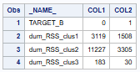

Extra Credit (45 pts):

Task #1

As we have seen, variable transformation can make a distribution “more normal” and, thus, can reduce, if not eliminate, any model leverage resulting from extreme values.

- Using SAS, transform LIFETIME_GIFT_AMOUNT by applying the log() function. Show, side by side, the before and after histograms along with the before and after skewness values.

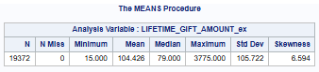

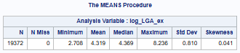

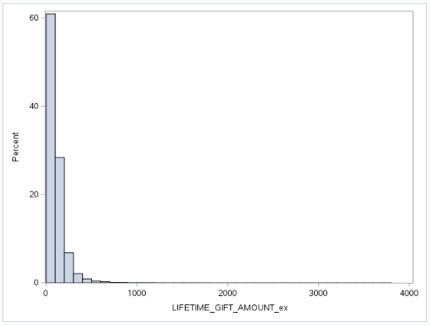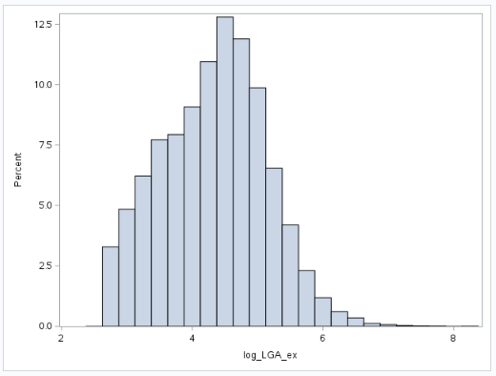

- Test for extreme values using the log version of LIFETIME_GIFT_AMOUNT. Use the clustering method with pmin=.006.
  - Do you still find extreme values? If so, what is the cutoff value in terms of LIFETIME_GIFT_AMOUNT (not log(LIFETIME_GIFT_AMOUNT)). How many extreme values do you find? Explain fully.

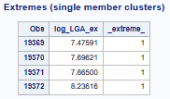

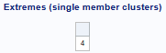

Yes. Used a log value of 7.47590 as a cutoff value. Four extreme values were identified. See the results above.

  - Assuming these extremes are valid values, what should we do about them? Explain fully.

Carefully identify the observations that are extreme (more than likely the four highest values in the LIFETIME_GIFT_AMOUNT distribution), and share that information with the client. With the client’s permission, after performing model testing using the logarithmically transformed distribution for LIFETIME_GIFT_AMOUNT, a modified transformed distribution with the identified extreme values removed could be tested as well to see which would perform better.

Task #2

After this reduction (see Task #3 above) in the spareness of the levels of RECENT_STAR_STATUS, using SAS’s PROC FREQ, calculate the new Pearson chi-square statistic. Is there still a statistical association between RECENT_STAR_STAUS and TARGET_B? Explain fully and show relevant output from PROC FREQ.

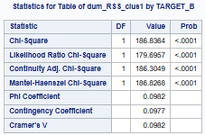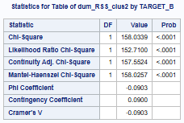

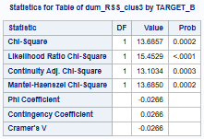

Because the reduction is being expressed in the dummy variables created for the three reduced categories, Chi-Square test information was generated for each of them. Given the highest Chi-Squared p-value of 0.0002 of the new categories is less than an alpha of 0.050, we can reject the NULL hypothesis of no statistical association, and conclude that there is some relationship between the new RECENT_STAR_STATUS reduced categories and TARGET_B. Both variables, dum_RSS_clus1 and dum_RSS_clus2, have very high Chi-Square values (186.84 and 158.03 respectively). The dum_RSS_clus3 variable has a Chi-Square value of 13.69 that is much lower. Noting that there is only one degree of freedom, this may be acceptable though.

Task #3

Using R, create a WOE table for RECENT_STAR_STATUS which applies an overall threshold of 30.
- Show here an R-generated, neatly formatted output table which has columns (i) RECENT_STAR_STATUS category; (ii) total frequency; (iii) frequency TARGET_B = 1; (iv) frequency TARGET_B = 0; (v) odds ratio; (vi) WOE; and (vii) information value.

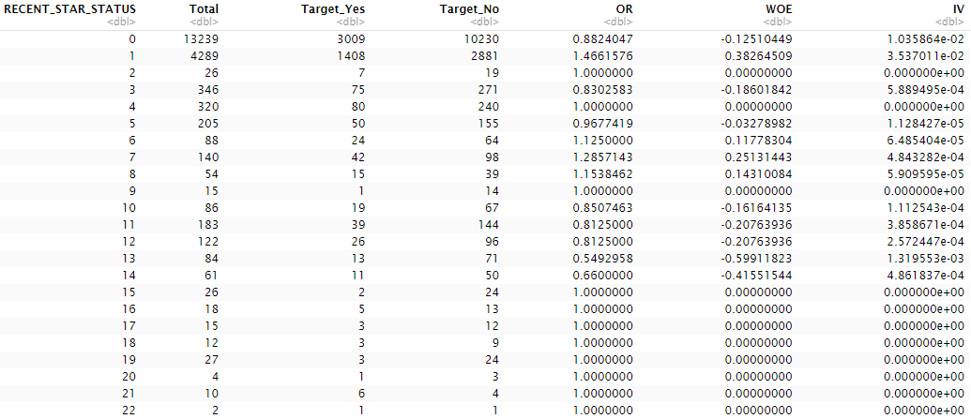

- Show here your neatly formatted R code.

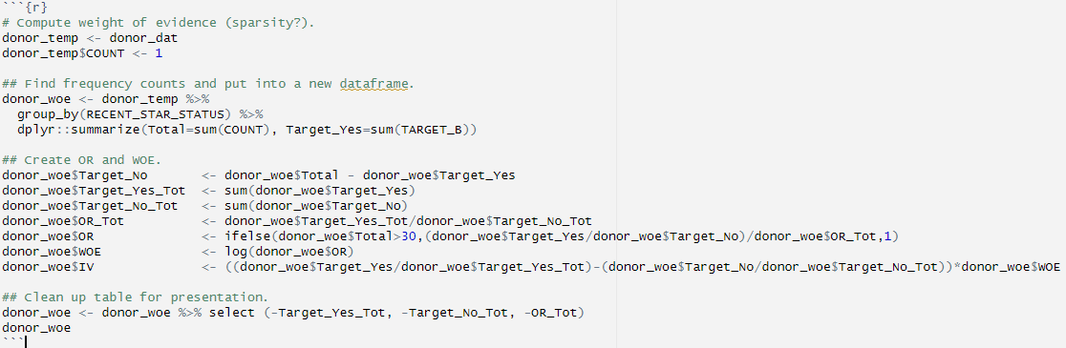

- When the threshold is not met, why is the odds ratio 1.0? Explain.

The odds ratio of 1 represents an average odds event from the odds event calculations from all the categories. When the odds ratio is greater than 1, the likelihood of Target_Yes is better than average, but when it is less than 1, the likelihood is less than average. Given the WOE value is the log of the odds ratio, and the natural log of 1 is equal to 0, it makes sense to identify the odds ratio as 1 for when the desired threshold is not met, making it easy to distinguish in the output.

- Find and show here the variable-level information value. Interpret its value.

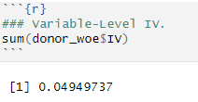

A variable-level information value of 0.049 is less than 0.1, and would be considered a weak predictor for the model estimation of Target_B.

Task #4

Using either SAS or R, create a supervised ratio variable for RECENT_STAR_STATUS which applies an overall threshold of 30.

- Show here a code-generated, neatly formatted output table which has the following columns: (i) RECENT_STAR_STATUS Category; (ii) total frequency(count); (iii) frequency TARGET_B = 1; (iv) frequency TARGET_B = 0; and (v)the supervised ratio.
- Show here your neatly formatted SAS or R code.
- Show here code-generated, neatly formatted output which reports the correlation between your supervised ratio and TARGET_B. Does the sign and magnitude of this correlation value make sense? Explain fully.

Homework deliverables:

- Word doc with your analysis and discussion, including all tables and charts.
- A SAS program with all code used for this assignment.

Refer to pre-recorded session #4 SAS code (Working with Dates) for examples.
See footnote 1.

